**Project Summary – Part 1**

# Description of the Volve field

The Volve field is a shallow water field located 200 kilometers to the West of Stavanger. It was discovered in the year 1993 and commenced production in the year 2008. At peak production, the Volve field produced 56,000 barrels per day and production a total of 63 million barrels in its 8 years lifetime from 2008 to 2016. The recovery percent of this field was 54%. Equinor (formerly Statoil) in 2018 together with its license partners released data to the general public for research and training purposes. Data released included high-resolution geophysical logs, subsurface measurements, various drilling and geological reports, and the reservoir model.

# Project Tasks

In this project, we perform a geomechanical analysis of the Volve field. To begin with, as we had access to only the CMG software, the reservoir model of the Volve field was converted from Eclipse file format to CMG file format. The reservoir model was able to provide us with the geology of the Volve field, the grid block location of the wells and the grid block numbering convention used in the software used. To populate the grid block with reservoir properties, well log files from the Volve dataset were used. An efficient Python code was written to interpret the dataset. The interpretation process is summarized below

1. A GitHub repository was created to facilitate easy collaboration amongst members of the group.
2. To enable quick reproducible interpretation of the logs, a Python library was created. The Python library was named PyLasMech.
3. The PyLasMech library made use of existing python libraries such as Numpy for numerical computations, sys for system manipulations, os for operating system manipulations, lasio for .las file operations.
4. The Python library contained the script files IO.py, plot,py, and utils.py.
5. The IO.py contained a class Params with methods for getting index of a curve, getting common non-nan index from a list of curves among others
6. The IO.py script also contained methods for searching for files, reading, creating, saving and printing las files among other methods
7. The plot.py mainly contained methods for plotting log data .
8. The utils.py contained methods for performing other utilities which would assist in making calculations and plots. Amongst the methods in this script include stress polygon plotting, line intersection calculations, moving averages among others.

After completion of the PyLasMech library, the library was used in the calculation of geomechanical parameters (S1, S2, S3, E, v, UCS, PP) and quality checked by other members of the group to ensure accuracy and applied to all well logs. The formulas used are as stated below

**Calculation of principal stresses**

We have the well log data that can be used to calculate Sv using the relationship:

*Lang et al. (2011)* provides a relationship relating maximum horizontal stress (SHmax) and minimum horizontal stress (Shmin) with vertical stress (Sv):

Where k is a constant defining the ratio of SHmax to Shmin. It ranges from 0 to 2 where k=0 represents isotropic horizontal stress system.

Among limited stress regime studies available for Volve field, *Sen and Ganguli (2019)* use fracture gradient as the Shmin gradient and use the above relationship to calculate the SHmax gradient for four wells in the volve field. Their findings suggests that Sv>SHmax>Shmin, which means that the stress regime is normal faulting regime. Upon examination of their findings, we reach to the conclusion that the stress gradient for horizontal stresses can be roughly estimated by the relationships:

The three principle stresses are named S1, S2 and S3 for simplicity.

**Calculation of Pore pressure**

Pore pressure at different depths is calculated using the hydrostatic pressure gradient. Density is assumed to be 1g/cc.

**Calculation of Rock Porosity (φ)**

The rock porosity (φ) is calculated from density log using the following relationship

Rock porosity can also be calculated from Athy’s equation using effective vertical stress, .

Porosity is given by

**Calculation of Young’s Modulus (E) and Poisson’s ratio (ν)**

Elastic properties of the rock can be calculated from Shear wave velocity (Vs) and Compressive wave velocity (Vp) logs.

Shear modulus of Elasticity,

Poisson’s ratio, Young’s modulus,

**Calculation of Unconfined Compressive Strength (UCS)**

The unconfined compressive strength (UCS) is calculated using the relationship for North Sea:

(Kalani, 2018)

For wells without explicit values given, the following correlation was used

*(Horsrud, 2001)*

*(Bradford, 1998)*

However, the correlation is for North sea shale which does not yield in a good result for sandstone reserve like the Volve field. A sample plot of geomechanical properties is shown below

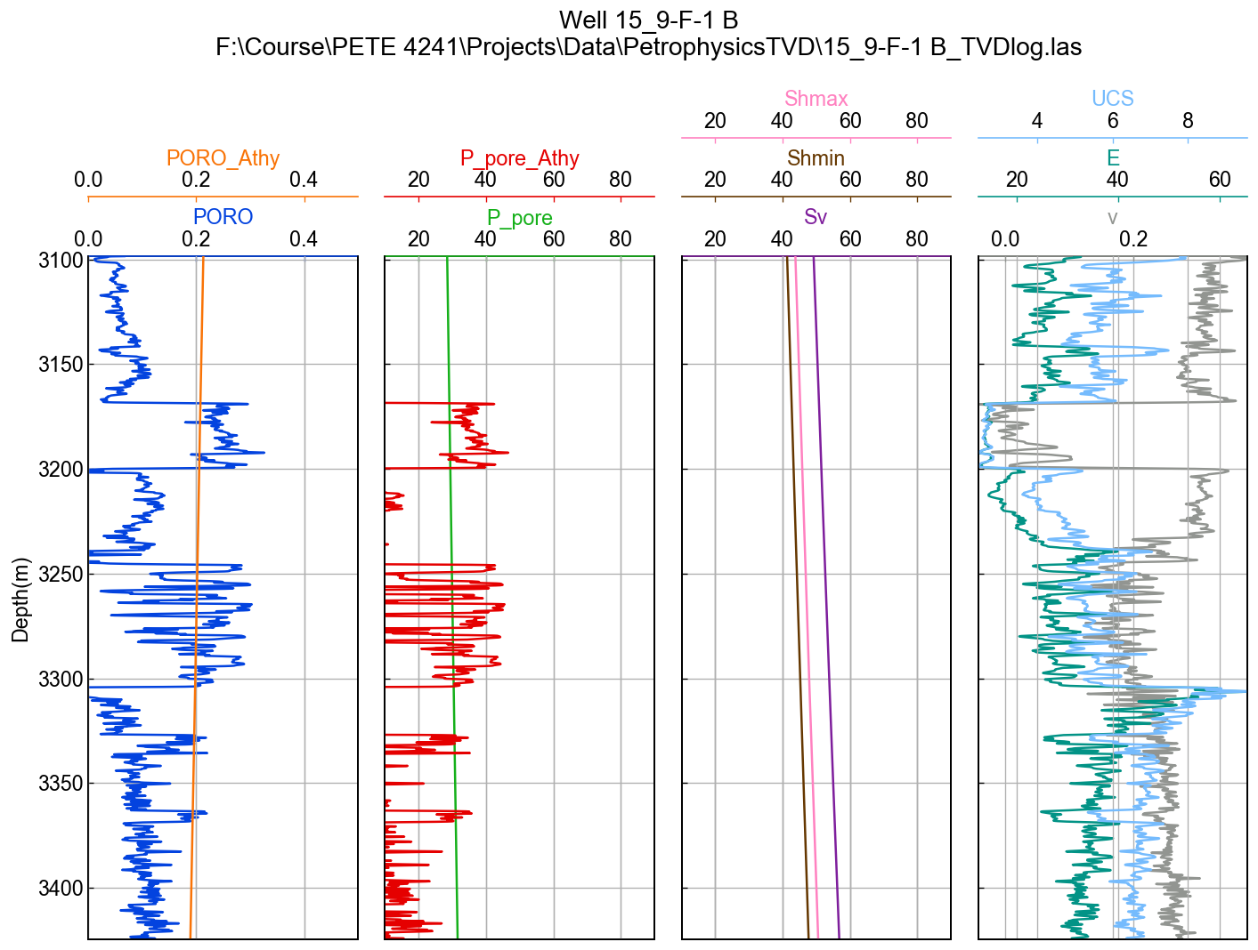Fig: porosity, pore pressure and geomechanical properties calculated using well log data.

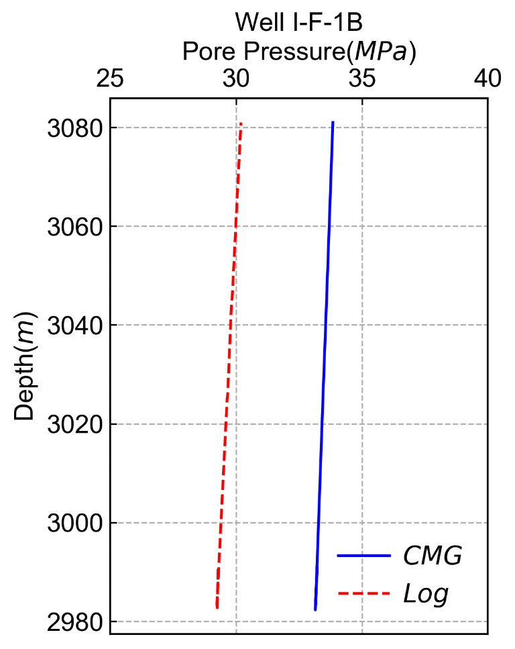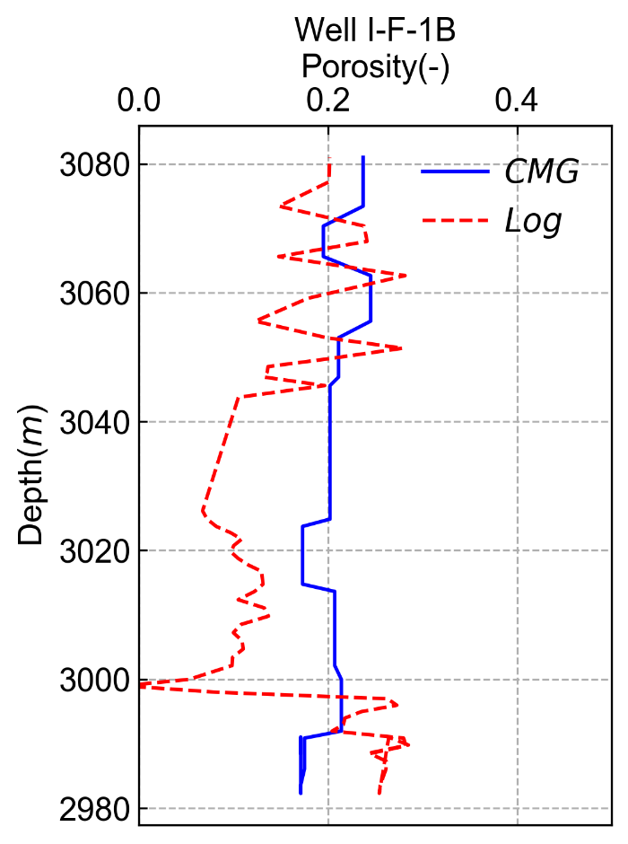

# Fig: Porosity and pore pressure comparison of well log data and CMG data

# GitHub Repository

All other files have been uploaded to the GitHub repository <https://github.com/BinWang0213/PETE4241_19SP_ProjectCode>

**References**

Kalani, M., 2018. Multiscale seal characterization in the North Sea Implications from clay sedimentology, well logs interpretation and seismic analyses.

Karstens, J., 2015. Focused fluid conduits in the Southern Viking Graben and their implications for the Sleipner CO2 storage project (Doctoral dissertation, Christian-Albrechts-Universität).

Lang, J., Li, S. and Zhang, J., 2011. Wellbore Stability Modeling and Real-Time Surveillence for Deepwater Drilling to Weak Bedding Planes and Depleted Reservoirs. Presented at the SPE/IADC Drilling Conference and Exhibition, Mar 1-2. SPE-139708-MS.

Sen, S. & Ganguli, S. (2019). Estimation of Pore Pressure and Fracture Gradient in Volve Field, Norwegian North Sea. SPE Journal. SPE-194578-MS.

Sleipner Øst and Volve Model Hugin and Skagerrak Formation Petrophysical Evaluation, 2006.

Bradford, I. D. R., Fuller, J., Thompson, P. J., & Walsgrove, T. R. (1998, January 1). Benefits of Assessing the Solids Production Risk in a North Sea Reservoir using Elastoplastic Modelling. Society of Petroleum Engineers. doi:10.2118/47360-MS.

Per, Horsrud. (2001). Estimating Mechanical Properties of Shale From Empirical Correlations. SPE Drilling & Completion - SPE DRILL COMPLETION. 16. 68-73. 10.2118/56017-PA.

<https://www.spec2000.net/05-abrev-log.htm>

<https://www.spec2000.net/05-logaliastable.htm>